Every Contact Counts Annual Report (June 2013 – Jan 2015)

What is Every Contact Counts? (ECC)

Every Contact Counts is a training programme to improve the health & wellbeing of the people who live and work in the Wakefield District. We know that In the Wakefield district we experience high levels of health inequalities - this means that depending where in the district you live, your chances of living a healthy life and experiencing good mental wellbeing vary enormously.

In the UK today, the greatest burdens of disease and premature death relates to long term conditions such as cancers, heart and respiratory disease. These diseases are strongly associated with lifestyles and the health behaviours we choose, (including smoking, alcohol consumption, substance misuse, unhealthy eating, lack of physical activity and obesity etc.) Tackling these behaviours and supporting people to make some small changes to their lifestyle is key to preventing future disease and promoting health.

We really need to work together to help to overcome these inequalities and one way that we can achieve this is to capitalise on “every contact” with an individual.

The programme targets front line staff/people who go into others homes, talk to people face to face or over the phone as part of their day to day work - or really anyone who has the opportunity to talk to others – and that’s most of us. This training will help people to gain confidence and knowledge to talk to people about health & wellbeing & signpost or refer people to relevant services making sure that ‘every contact does count’.

Since June 2013 – Jan 2015 we have delivered thirty 3 hour training programmes with a total of 355 trainees. These include employees all across the district from: Admin, library, housing officers, care workers, pharmacy, neighbourhood community workers, benefit staff and many more.

How well did we deliver the training?
The facilitators scored very highly when the trainees were asked how knowledgeable they were about the topics delivered and when asked if they would recommend the course to their colleagues the majority would do so.

I would recommend this course to my colleagues

Although very informative not everyone thought it was relevant to their role in the workplace but still scored quite highly (see chart below) in that they would recommend the ECC training to colleagues.

What was the most useful / interesting part of the course?

The general comments were very positive and that the entire course was very useful and in some cases a real eye opener. In particular people mentioned learning about the deprived areas in the Wakefield area and the effects of unhealthy lifestyles such as smoking and obesity. The general health tips that apply to everyday life and the contacts and resources, including safeguarding, signposting, mental health and dementia were also mentioned. The facts, figures, statistics and visual aids used such as the fat blob were very helpful as were the information packs to take away.
Quotes
“pleased the trust recognises the need for such courses”
“the course was brilliant, really enjoyed all the information I have learnt”
“every part of the course was useful as I use this in my job and given me the confidence to help my patients”
“The leaflets in the pack will be helpful”
“how many calories in alcohol!”

What was the least useful part of the training?

Having been asked what was the least useful part of the day the overall comments were that the question was not applicable as the entire course was very useful. There were some that would have liked more information on signposting and safeguarding (see below) rather than all the detail about smoking and obesity. Many said they already had training or knew much of the information so thought it was not relevant to them.

Quotes
“talking about social workers, discussion needs to be specific to population”
“Safeguarding, as I have a lot of experience already. Would be useful to expand on safeguarding”
“alcohol & smoking don’t do either”
“probably safeguarding because it was so brief and we didn’t talk on adult safeguarding”

Were there any areas you would have liked more detail?

When asked if there were any areas they would have liked more detail the overall feedback suggested that all areas were covered well and were interesting. Some mentioned that the information on the slide sheets was not clearly visible to refer back to. As some of the trainees were already knowledgeable about many of the topics some would have preferred more in depth detail on the following issues: mental health, dementia, vulnerable adults, safeguarding and how to raise issues and techniques without offending people. More examples of specific services to refer to in local area would be helpful to reflect situations they may find themselves in.

Quotes
“Mental health, teams/services you can refer to such as mental health services etc”
“no this can be covered in further targeted training”
“yes, more time spent on how you can raised these issues & techniques involved without offending people”
“Pharmacy as a link or tool to health living?”
“examples of what services to refer people to would be helpful. These could be done to reflect situations people may find themselves in”

Recommendation: The training should be re-designed to focus more on developing trainees’ skills in raising the issues balanced with raising knowledge and awareness of health and wellbeing issues.

General comments

Most comments were that the length of the course was just right and really interesting. There were still quite a few who said it was trying to cover too much in a short time so felt rushed at the end. Because of this some thought it should possibly be all day. The venue was said to be really good but a few comments that the room was cold and the seating was not so good as had to keep turning around.

Recommendation: Develop a session plan and condense the training further to ensure the session doesn’t feel rushed.

What difference did the training make to knowledge and confidence?

As the figures show in the chart below, the majority of people improved their knowledge and confidence around each area of the training. The most significant improvements are learning the aim of Every Contact Counts (Q1) and improving the knowledge around life expectancy of people living in disadvantaged areas of Wakefield compared to the more affluent areas (Q2). They were also much more confident in talking to people about health & wellbeing as they now had more overall knowledge (Q11). It also shows that after the training they were more aware of the wider determinants of health (Q3) and a large improvement in knowing the recommended time and frequency for adults and children to be physically active each week (Q6). There was also a large increase in knowing the department of health’s recommended safe amount of alcohol units each day for men and women (Q8). Also there were large improvements in knowledge around long term conditions (Q10) and knowing what to do if someone was experiencing mental health problems (Q9).

There were some questions where the increase in knowledge was not quite as high but were still quite significant. These were knowledge of health conditions related to obesity and calorie intake (Q4, Q5), which is possibly due to the fact that since the evaluation was designed the training had changed and no longer placed as much emphasis on these areas. The area where knowledge improved the least was naming the benefits of stopping smoking (Q7), however, this was still quite significant.

Recommendation: Look at how we can improve information and knowing what to do in awkward situations regarding mental health problems.

For any further information you can view the charts relating to this graph in the appendix at the end of this document .

Relevance of training & ability to apply it to role

When asked on the pre-questionnaire if they thought the course was relevant to their work roles, 41.9% were undecided and stayed neutral whilst 47% agreed or strongly agreed. Post training this rose by 18.1% to 65.1%.

When asked if they could easily apply the training to their role/work 67.4% said they could and 84.7% thought they could use it in their own life/home/community.

Have you applied what you learnt on the ECC training? In your Role / Work – own life/home/community

In a follow up survey the trainees were asked if and how they had applied what they learnt on the Every Contact Counts training in their role/ work, 67.3% said they had and 69.5% had used it in their own life/home or community.

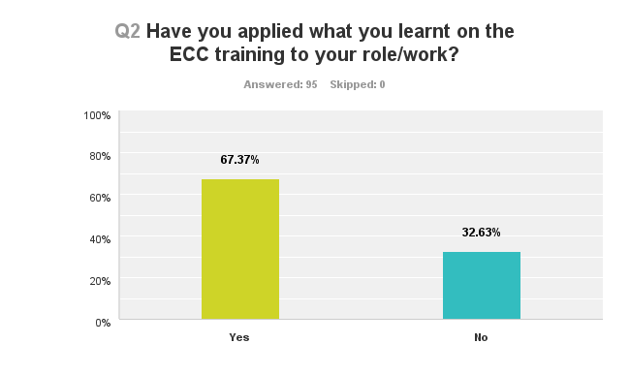

One of the key themes throughout the evaluation is that it has helped enormously in raising awareness of health & wellbeing issues helping to signpost to other agencies such as social services and stop smoking service and confidence in knowing who, when and where to refer to and helping other people to also raise awareness.

Quotes
“It’s also raised awareness regarding health and mental health issues and being able to give advice and signpost to other agencies”
“Better informed to give out current up to date information”
“The training provided insight into health issues that the health inequality case workers at WDH deal with on a daily basis”
“Being more confident in spotting signs of depression in older people I work with in care homes and home visits to signpost to other agencies to help with social isolation.”
“Highlighted to other staff members who deal with the public so they have a better understanding. Also used this when assisting at the Mayor’s charity event.”
“listening to members of the community understanding how I can help individuals who usually have a complaint about their locality, health, family or life in general”
“passed on information and contacts to community groups and other agencies”
“I have applied my knowledge of the ECC training in my everyday tasks. Working in Sport and Active lifestyles, I feel like this course was very beneficial to me and I still use the things I have learnt”.

What may have stopped you from applying what you learnt?

When asked what may have stopped people from applying what they learnt in their role/work most comments were that they had not needed to and it did not apply to their role or have not had the chance to use it yet but would they would if the need arose.
A few felt that when helping to complete forms such as housing benefit on reception and over the phone that it would not be appropriate to tell people what they should give up (such as smoking) as they would probably say it was none of my business.

Quotes
‘The training was great but there is just nothing that has required me to put it to use as everyone in my specific area seems fine - Although I would have, had it been necessary’
‘Have not had the opportunity’
‘Not relevant to my role’
‘There has not been a need in the clients that I have seen’

Have you applied what you learnt in your own life / home / community?

When asked how this had been applied in their everyday life they were more positive to have a healthier lifestyle and do more exercise and also were much more aware of fat content and calories in food and alcohol levels in drinks. Some also used leaflets to inform their families to eat healthier and stop smoking. Many have passed on information to their friends and family. One particular story turned out well through having been on the
training (see quotes below).

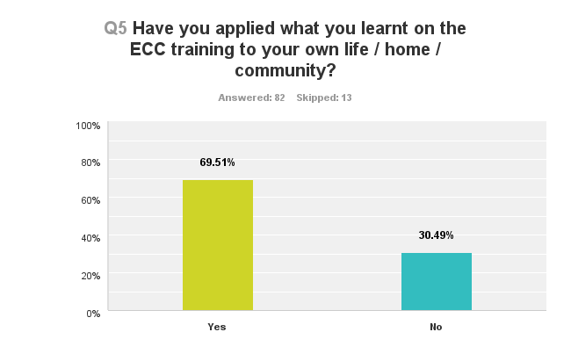
Quotes:
‘My uncle bill lost his wife in august 2013 he is 74 and on his own. Myself my family and his neighbor look after him. he had a couple of falls and ended up in hospital because he had taken too much insulin while in hospital the doctors said they would arrange some help for him when he got home. Unfortunately he was released early and this didn’t happen. I remembered my training and I phoned the health and well being team. They visited my uncle recently and on the back of that he’s had a visit from my therapy who are going to adapt his home. He now gets his medication in blister packs so he doesn’t forget what to take. Without this training I wouldn’t have known what help was out there’.

‘Being interested in sport and health myself, I have taken all of the information on board and adapted it in to my everyday life. For example, the smoking information I used to convince my Grandma to stop smoking and used the leaflets I was given on the course to keep her motivated throughout. Within my friendship group, I am always discussing the health issues and facts I learnt in to everyday conversations in order to spread awareness. In my house, I speak regularly about the dementia awareness segment as I felt this part the informative and I still remember the information clearly’

“I have used it mainly in dealing with my Mother who we expected was suffering from dementia. We contacted Social Services and other agencies and have managed to get mum help in several different ways.”

‘I lead a healthier lifestyle by eating healthier, take more exercise and drink less alcohol and encourage my family and friends to do the same’.

What may have stopped you from applying what you learnt?

When asked what might have stopped them in their everyday life they said this was not relevant as they were already aware and were living a healthy lifestyle and were sensible with what they ate and exercise. Some said the opportunity had not arose or they thought it was not applicable to them.

Quotes:
”have not had cause to use it”
I was already applying it anyway”
“I don’t use anything outside of work”
“have not needed to, already aware of the decisions required to opt for a healthy lifestyle”
“I think in my own life I already have a sensible approach to exercise, outdoor activities, alcohol etc.”
‘I was already applying this anyway’

Any other comments about Every Contact Counts?

Reading through the comments people have made the overall feedback that the training is
very informative and beneficial and has inspired people to make better choices and promote to other colleagues, agencies and/or their family and friends.

Comments
A very enjoyable course, very informative and hand-outs were really helpful
Really beneficial and facts and figures were interesting although don’t expect to use it in my working situation
Inspired me to make better options and promote things I learnt at events I may be involved in etc

Comments
The two women who conducted the training were absolutely wonderful and it was a pleasure to be in the training - I really enjoyed it and it was incredibly informative without being a huge lecture on what’s bad and what's good

Me and the other Apprentices see still talk about the drinking segment and dementia awareness regularly as they had a big impact on our lives.

Every Contact Counts really helped me to get the knowledge on health and wellbeing within the district and inspired me to make better options and promote things I learnt at events I may be involved in etc. I have educated my family on the dementia segment which they found very interesting and I hope to continue my learning on these subjects

Everyone who works with communities, people groups, families etc. should attend to gain knowledge to impart to others and to become aware of the help and support which is on offer within the district

Recommendations

- The training should be re-designed to focus more on skills in raising the issues balanced with raising trainees’ knowledge and awareness of health and wellbeing issues.
- Develop a session plan and condense the training further to ensure the session doesn’t feel rushed.
- Recommendation: Look at how we can improve information and knowing what to do in awkward situations regarding mental health problems.

Appendix

Q.1

Q.2

Q.3

Q.4

Q.5

Q.6

Q.7

Q.8

Q.9

Q.10

Q.11

Q.12

