Kent Surrey and Sussex Make Every Contact Count
Introduction
The aim of the Kent Surrey and Sussex (KSS) MECC approach is to support public facing workers to “make every contact count”. It is about using opportunities to maintain or improve mental and physical health and wellbeing and having a healthy conversation either as a very brief intervention or a slightly more developed brief intervention(s) and signpost:
- Looking beyond specific issues or conditions
- Listening and asking the right questions to find out about underlying health needs or concerns
- Delivering brief advice and then and/or signposting to other support

Although there are four parallel strands weaving through our MECC implementation plan; supporting organisational and staff preparation or readiness, developing regional training, delivery and evaluation. For the purposes of this paper the training element to date will be reported.

HE KSS Workforce Development Programme
This MECC project is part of a wide programme of work funded by Health Education Kent Surrey and Sussex (HE KSS) for development of the public health workforce. A detailed delivery programme has been agreed by the 6 Directors of Public Health which also includes support for practitioner registration and supporting the transition of health visitors into public health. This funding has enabled MECC to become a tangible movement within the region and place it firmly within the local landscape, linking with other HE KSS and regional public health work streams.

National Drivers
The recent NHS Five Year Forward Plan emphases prevention of ill health and disease whilst making a commitment to support the NHS workforce improve their health and lifestyle. Similarly publications such as The Royal Society of Public Health report Rethinking the Public Health Workforce identified that approximately 20 million people in England have the potential to be part of the wider workforce, across 57 occupation groups which include a broad range of the public, private and voluntary sectors as well as 5 million people providing unpaid care and support. MECC is therefore not a task of one particular workforce or sector it is about developing a wide workforce of staff working with the public and supporting them to become confident individuals able to offer a low level intervention around health improvement. Within our training approach we have therefore aimed to offer an inclusive model suitable for a diversity of workforces.

Defining a Cogent KSS Programme
The aim of the KSS programme is to implement a cogent MECC plan across the six local authorities in KSS. Until now there has been little coordination of activity or measure of outcomes, and no common definition of what MECC means. MECC has been interpreted differently across authorities and local implementation has reflected and been modelled by local understanding, As such a feature of KSS work has been to develop a regional understanding of what MECC is and how previous or current behaviour change initiatives fit with the MECC philosophy. Creating a common definition also aims to support MECC development with staff groups or arenas that have not traditional seen themselves as part of a wider public health workforce.

Initially the London South Bank University were commissioned to undertake a scoping review from July-September 2014. The subsequent report Implementing ‘Making Every Contact Count’: a scoping review outlined the various definitions across the country of MECC and recommended KSS regard MECC at levels 1 (brief advice) and 2 (brief intervention). From this report a document was presented to the Directors of Public Health recommending training programs are implemented at Level 1 - awareness raising MECC e-learning provided to all staff as part of induction/mandatory training and refreshed every three years and Level 2 skills training: one day training on initiating difficult conversations and basic motivational interviewing principles with follow up annual refresher using the online materials.

Having explored the pertinent policies, strategies and MECC approaches across the country a shared vision for MECC across the region has been adopted. This document proposed a triple definition across KSS that could be used by LA’s, organisations, service providers, trainers and workforces. These descriptions range from a simple tagline, a sentence long definition and a narrative definition. This recognisable regional definition has helped ensure consistency, common understanding and a core MECC identity, and that reflects both organisational and individual roles and commitment.

Developing the KSS Programme
Having adopted a core definition developing of a regional training model has progressed. MECC is principally about behaviour change and building on the NICE guidance Behaviour change: general approaches, the work done by NHS Yorkshire and the Humber in 2009, and the Prevention and Lifestyle Behaviour Change Competence Framework (PLBCCF). KSS have designed a model of training that promotes MECC, as an instrument to change individual’s risky health behaviour to a healthier one. Using the transtheoretical ‘stages of change model” our approach fits into the behaviour change cycle as its primary aim is to help individuals move from contemplation to preparation and action, by giving brief health advice and guiding action. By harnessing a recognised method for providing health behaviour advice the 4A’s model a sequential (Assess, Advise, Agree, Assist) competency and skills base for delivery has been devised (see figure 1). This approach allows MECC to dovetail with other regional programs, such as Health Coaching, Health Trainers and specialist behaviour change services.
The Training Model
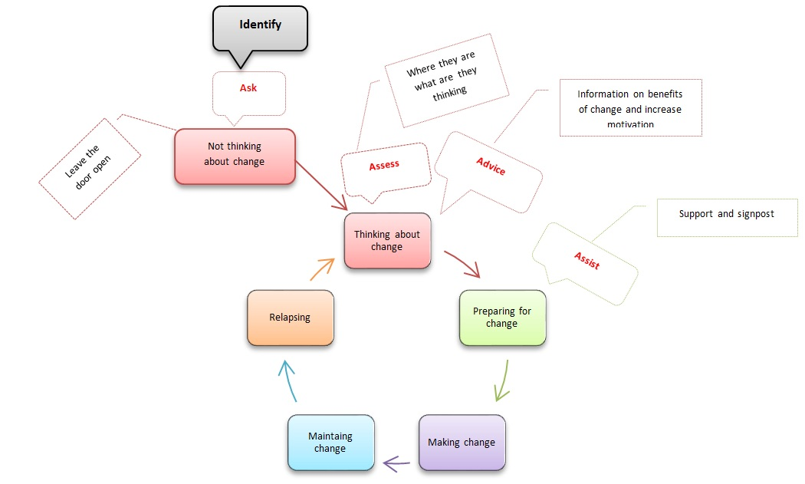
The training model within KSS is based on workforce competencies. By mapping the Prevention and Lifestyle Behaviour Change Competence Framework (PLBCCF)⁵ Level 1 and Level 2 competencies, against the 4 A’s, key Skills or Health standards and lifestyle topics, the KSS MECC Competency Framework (KMCF) sets out the skills and competencies workforces within KSS will develop to undertake a healthy conversation and describes the learning outcomes and potential assessment tools for MECC training or other commissioned behaviour change training within the region. The KMCF has grown from incorporating knowledge of behaviour change and levels of intervention overlaid by the 4A’s. This systematic appraisal has been translated into a comprehensive incremental training model that includes core and skilled competencies. Reviewing current approaches has also highlighted the need to include identification of opportunity as part of any skills based training as not all contact maybe an appropriate situation for an intervention (see figure 1).

In designing the KSS MECC training model collaboration has been undertaken with HE Wessex and Thames Valley. Across these three regions a core training framework based on the KMCF is being established to support wider workforces to achieve MECC skill. The KMCF has also been shared and recognised nationally.

NHS England (2014) Five Year Forward View. DH, London
Royal Society of Public Health (2015)Rethinking the Public Health Workforce
London South Bank University (2014) Implementing ‘Making Every Contact Count’: a scoping review
KSS MECC Leadership Group (2014) Making Every Contact Count in KSS: Directors of Public Health and PHE Centre Director Report
NICE (2007 and 2014) PH6 Behaviour change: general approaches
Yorkshire and the Humber NHS (2010) Prevention and Lifestyle Behaviour Change Competence Framework
Prochaska, J. O., & DiClemente, C. C. (1986). Toward a comprehensive model of change (pp. 3-27). Springer US.
Glasgow, R. E., Emont, S., & Miller, D. C. (2006). Assessing delivery of the five ‘As’ for patient-centered counseling. Health Promotion International, 21(3), 245-255.

